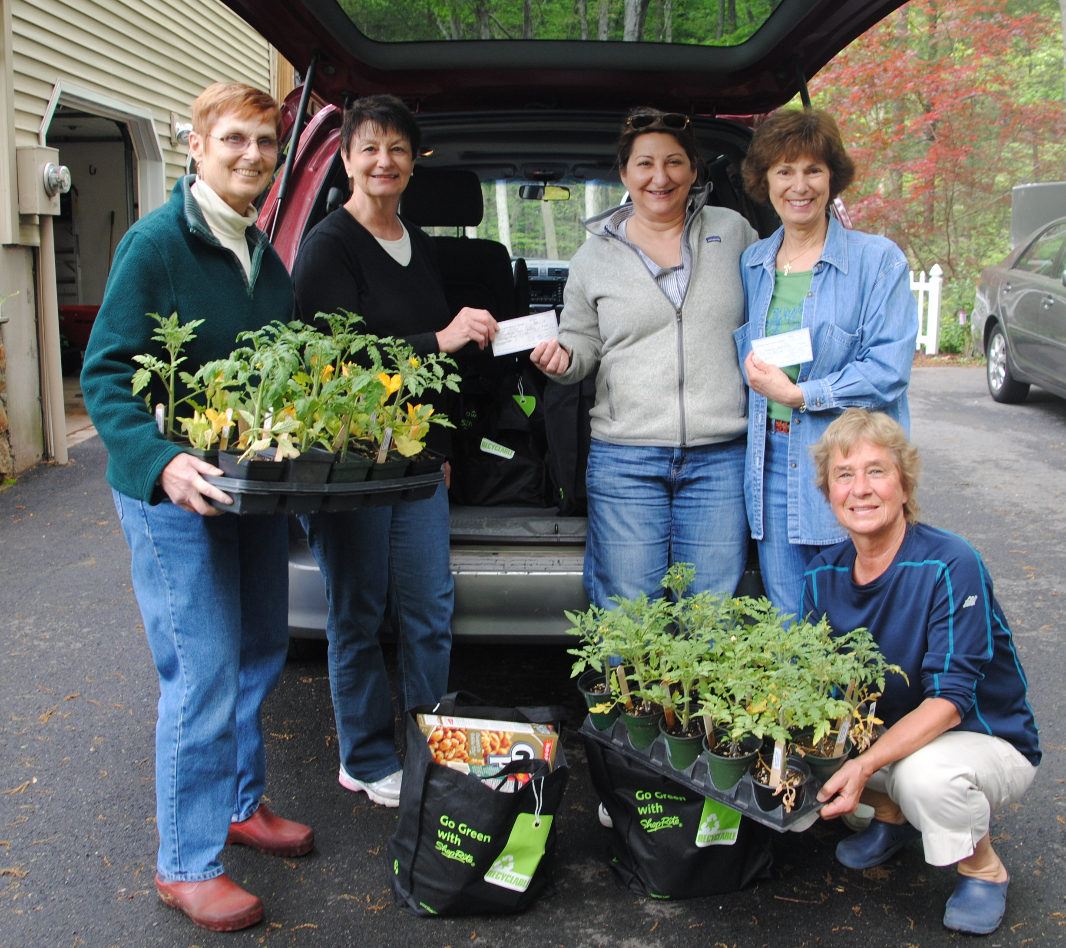
(L to R) Linda Broker and Rita Giannotti of the Suburban Garden Club of Cheshire, Patty Hartmann and Jean Abate of the Cheshire Food Pantry and Pat Archibald of the Suburban Garden Club with two checks as well as some of the bags of food and vegetable plants the Club donated to the Food Pantry.
For Immediate Release - May 26, 2014
Contact: Susan Dillman, Suburban Garden Club of Cheshire, 203-272-9055
Suburban Garden Club of Cheshire donates to the Cheshire Food Pantry
On May 23 the Suburban Garden Club of Cheshire donated 175 vegetable plants, 30 bags of groceries, and $242 to the Cheshire Food Pantry.
The 175 vegetable plants were grown by Suburban Garden Club members over the past two months and included basil as well as multiple varieties of tomatoes and squash,. Many of these plants will be utilized in the Cheshire Food Pantry’s newly established vegetable garden. The rest will be given to Food Pantry clients so they can grow vegetables themselves.
The 30 bags of food were collected during a club-wide food drive. At their April meeting, Club members each took a reusable shopping bag provided by Shop Rite of Milford and brought the bag back to the May meeting filled with groceries.
The monetary donation was a combined effort. A box was placed at the check-out table at the Club’s annual plant sale encouraging customers to donate their change to the Food Pantry. A total of $42 was collected. The Suburban Garden Club donated an additional $200.
The Suburban Garden Club also donated 35 vegetable plants to the First Congregational Church of Cheshire for their new community garden. Vegetables grown in the garden will be donated to the Cheshire Food Pantry.

The Suburban Garden Club of Cheshire was founded in 1959 with the objective to encourage interest in all phases of gardening, promote better environmental practices and conservation of natural resources, increase knowledge in the artistic use of plant material in design and landscaping and assist in community beautification and civic involvement through member participation, contributions and charitable activities. For more information visit their website www.cheshiregardeners.org.

