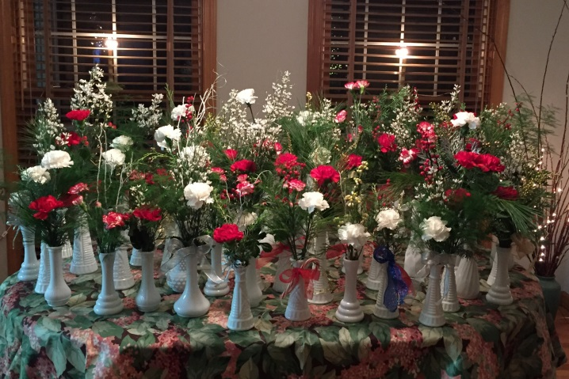
Holiday arrangements created for patients at Connecticut
Hospice and residents at The Highlands Healthcare.
Photos of other activities available on request.
For Immediate Release: December 18, 2014
Contact: Susan Dillman, Suburban Garden Club of Cheshire, 203-272-9055, sdillman@snet.net
Suburban Garden Club Spreads Holiday Cheer
Members of the Suburban Garden Club of Cheshire have been busy spreading holiday cheer throughout the community.
Club members created more than 50 individual holiday and winter themed floral arrangements in vintage milk glass vases and delivered them to patients at Connecticut Hospice in Branford and residents at The Highlands Health Care in Cheshire.
In a joint effort with the Cheshire Garden Club, members continued their annual tradition of supporting the Wadsworth Atheneum’s Festival of Trees and Traditions fundraiser. Members designed, created and donated a large wreath made of various types of permanent botanical spruce and pine and decorated with champagne colored Magnolia flowers surrounded by berries, fiddle heads and foliage.
Members also decorated several locations for the holidays. As they have for more than two decades, club members decorated rooms at the Ronald McDonald House and created holiday appropriate decorations for the interior and exterior of Phillips House Historical Society’s annual open house using mixed greens, nuts, fruits, seeded eucalyptus, boxwood trees and roping made of popcorn and cranberries. The front porch of the Cheshire Senior Center was adorned with pine roping, kissing balls and fresh greens, berries and bows in the window boxes. At the Cheshire Public Library, members placed a live blue spruce tree in a large planter at the front entrance and decorated it with silver and white ornaments representing the winter season.
##

The Suburban Garden Club of Cheshire was founded in 1959 with the objective to encourage interest in all phases of gardening, promote better environmental practices and conservation of natural resources, increase knowledge in the artistic use of plant material in design and landscaping and assist in community beautification and civic involvement through member participation, contributions and charitable activities. For more information visit their website www.cheshiregardeners.org.

