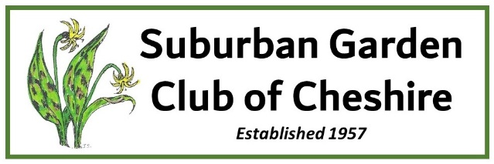

The Suburban Garden Club of Cheshire awards grants to individuals and organizations (to include public schools, civic organizations and non-denominational non-profits) on an annual basis for projects that support our goals to:

* Encourage interest in all phases of gardening,
* Promote better environmental practices and conservation of natural resources,
* Increase knowledge in the artistic use of plant material in design and landscaping, and
* Assist in Cheshire community beautification and civic involvement through  
   participation, contributions and charitable activities.

If your project relates to one or more of these goals, please complete the application below for consideration for a grant. Our grant deadline is April 30 and funds (maximum award is $350) will be awarded by June 15. All grants must be completed within one year of date of award.

**CONTACT INFORMATION**

Name of the organization/individual applying:

Address:

Contact person: ____________ / Phone number:______________ / Email address:____________

Brief Summary of your organization’s goals and mission:

Does the sponsoring organization hold tax exempt status? If so, which one:

**PROJECT INFORMATION**

Brief description of the project/program (please be specific):

Purpose of the grant (Please elaborate):

Describe how your project supports our goals:

Amount of money requested:

Estimate/itemize your project budget for this request, please note, an honorarium / fee for speaker(s) may be included:

Cheshire community benefits from the project and anticipated impact :

Send completed application and any supporting materials with “SGCC community funding application” in the subject line to: [grants.sgc.cheshire@gmail.com](mailto:grants.sgc.cheshire@gmail.com)