 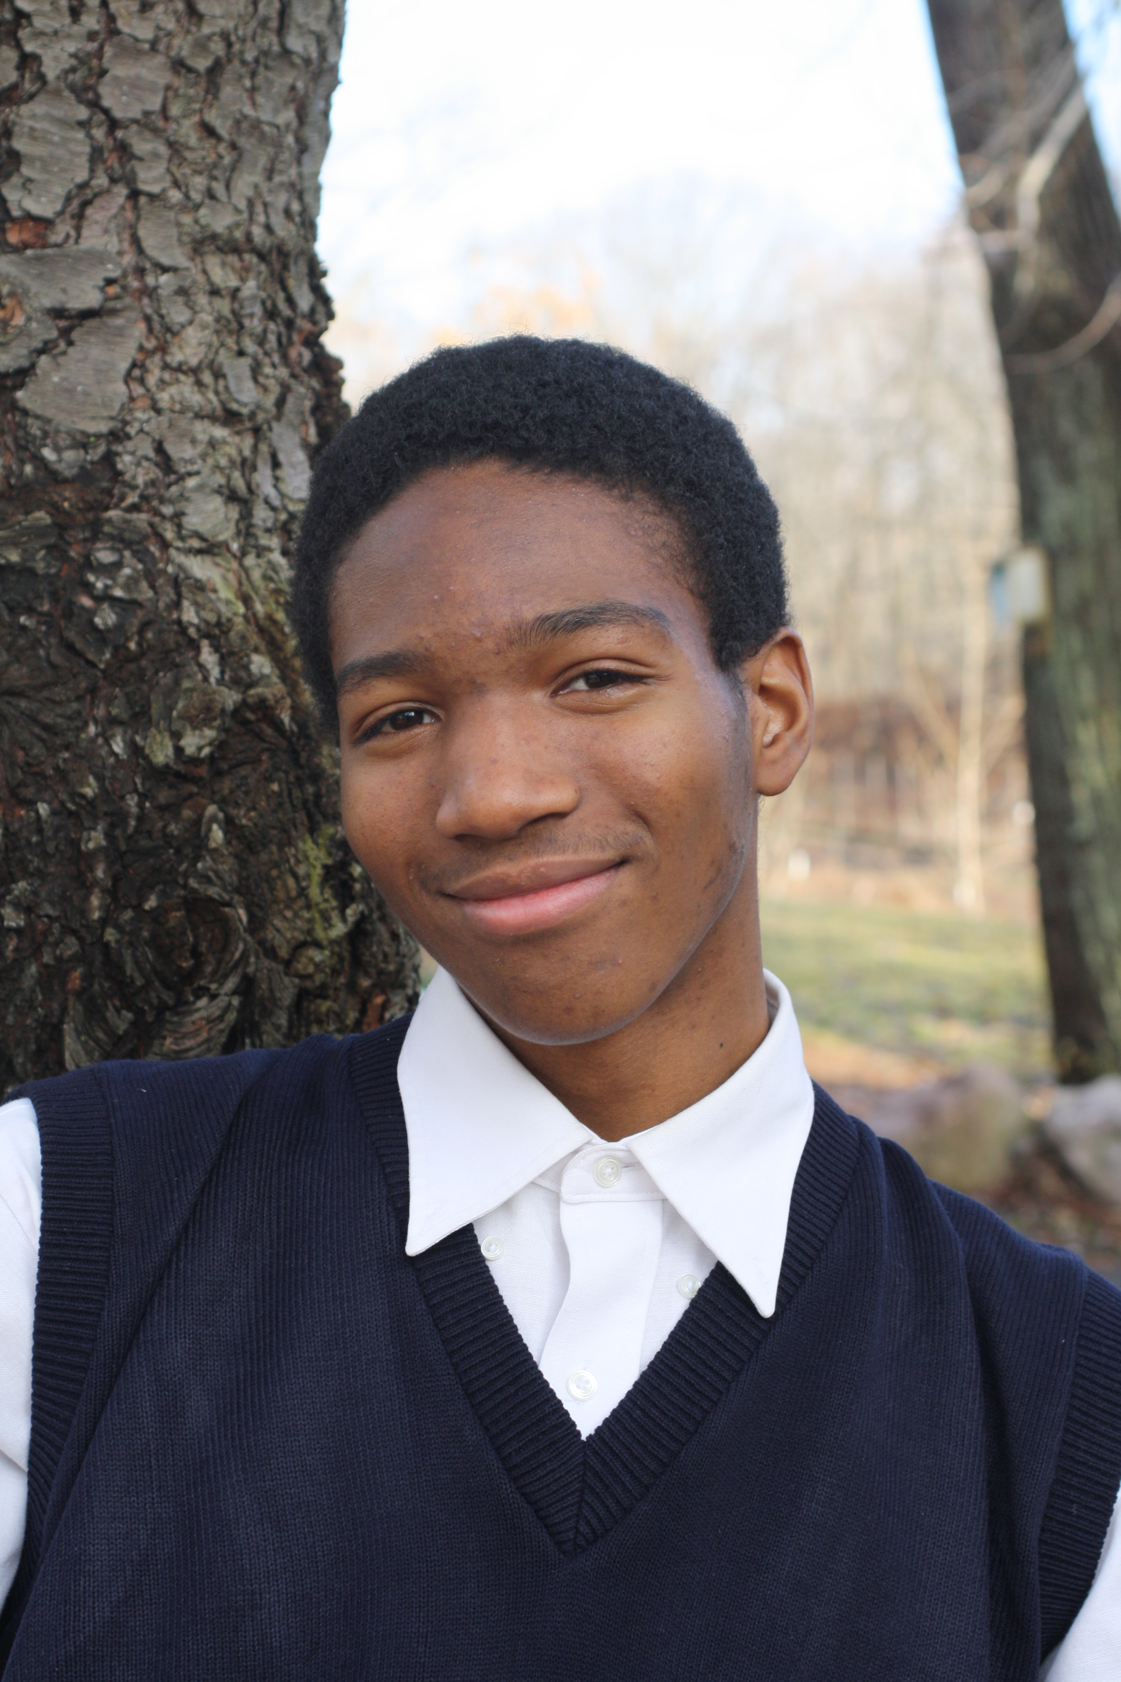 
Aida Feng Terrance Walker Forest Hoefflinger

For Immediate Release
June 2013
Contact: Heather Husain, Publicity Chairperson, 203-676-2507
Suburban Garden Club of Cheshire Awards Three Scholarships
The Suburban Garden Club of Cheshire is pleased to announce the recipients of our 2013 Club Scholarships. This year the club is thrilled to be able to award three scholarships.
The Cheshire High School Student Scholarship ($500) was awarded to Senior Aida Feng. She lives in Cheshire and will be attending Brown University in the fall, studying chemistry with attention to research in the environmental sciences.
The club’s collegiate level scholarship ($1000) has been awarded to 2012 Common Ground graduate and current Naugatuck Valley Community College student Terrance Walker of New Haven. Walker is pursuing a degree in Horticulture at Naugatuck.
This year the club has added a third high school scholarship for students at Common Ground High School in New Haven. The club is pleased to announce that the first annual "Suburban Garden Club Tripodina-Growell Scholarship” of $500.00 has been awarded to Common Ground Senior and Orange resident Forest Hoefflinger. He will be studying Environmental Science at Clark University. The scholarship was named to acknowledge the tremendous contribution the Tripodina Family, owners of Growell Inc. in Cheshire has made to the club by allowing the club to use greenhouse space to grow plants for their Annual Plant Sale. Proceeds from the Plant Sale fund the club’s Scholarship program.
Liz Cox who is Common Ground’s School Director stated that "Terrance and Forest are remarkable young people. They are exactly the sort of committed, capable environmental leaders that Common Ground High School aims to send out into the world. We are so grateful that the Suburban Garden Club can support Terrance and Forest as they continue to pursue their love of sustainable agriculture and the environment in college."

The Suburban Garden Club of Cheshire was founded in 1959 with the objective to promote a working interest in and study of all phases of gardening; to cooperate in the protection and preservation of trees, wildflowers, birds and natural resources; to encourage public planting and beautification; and to cooperate with other organizations interested in these objectives. The Suburban Garden Club holds affiliations with The Ronald McDonald House in New Haven and the Cheshire Historical Society.

Photos included of the three scholarship recipients

